Download Web Server - Agent Flow Diagram

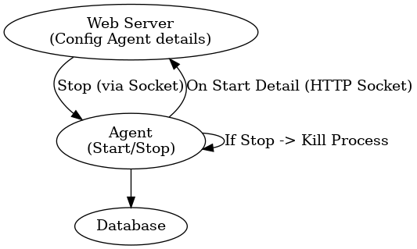

Here's the step-by-step guide:

Step 1: Create the Agent Folder

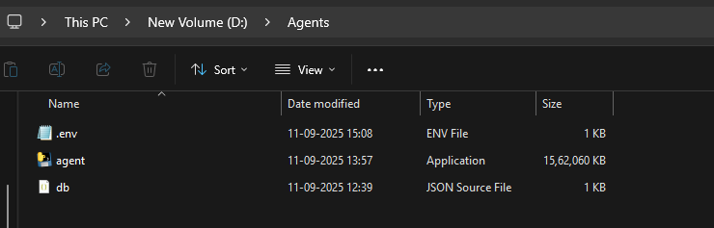

mkdir "D:\Agents"


Step 2: Create the db.json file

Create a file at D:\Agents\db.json with the following content. Add your database credentials in this file as well.


{
"databases": [
{
"type": "mysql",
"host": "localhost",
"port": 3306,
"db_name": "classicmodels",
"user": "root",
"password": "root"
},
{
"name": "PostgreSQL Database",
"type": "postgresql",
"user": "postgres",
"password": "root",
"host": "localhost",
"db_name": "llmtalktodb",
"port": 5432
},
{
"name": "MSSQL SERVER",
"type": "Ms_sql_server",
"host": "localhost",
"port": 1433,
"user": "sa",
"password": "admin@123",
"db_name": "IBMDB"
}
]
}



Step 3: Create the .env file

Create D:\Agents\.env with this content:

GROQ_API_KEY="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"
AGENT_ID="sql_agent_WIN"
SERVER_URL="http://94.136.186.31:5006"
EMBED_MODEL=BAAI/bge-small-en-v1.5
LLM_MODEL=gemma2-9b-it
EXE_PATH="D:\Agents\agent.exe"



Step 4: Download/Place agent.exe

Place the agent.exe file in the D:\Agents folder. Make sure the executable is compatible with your system.

Step 5: Run the Agent
Open Command Prompt or PowerShell and run:

cd "D:\Agents"
agent.exe



Step 6: Verify Cloud Connection
After running the agent.exe, it should:

- Connect to the cloud server at http://94.136.186.31:5006/api/index

- Show status indicating it's running and connected to the cloud

- Display the agent ID: sql_agent_Roshu

Important Notes:
1) Firewall: Ensure your firewall allows connections on ports 5006
2) Database Connections: Make sure your MySQL, PostgreSQL, and MSSQL servers are running
3) API Key: The GROQ_API_KEY should be valid

Expected Output:
When successful, you should see messages like:
- Agent connected to cloud server
- Agent running on http://94.136.186.31:5006/api/index
- Database connections established
- Ready to process queries

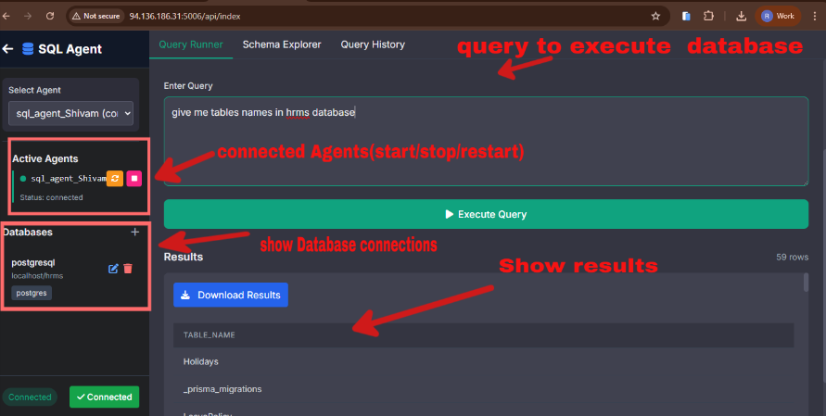

Prepared Executable files for download:
1) agent.exe
2) .env
3) db.json

Download Link :
https://drive.google.com/file/d/1xbh_wzE0iT065cWn3ywyJwB0HVSEsz6S/view?usp=sharing

Alternate api key for Use:
GROQ_API_KEY="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"

GROQ_API_KEY="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"

GROQ_API_KEY="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"

GROQ_API_KEY="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"

GROQ_API_KEY="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"

Overall Purpose
This agent allows users to query databases using natural language, automatically converting questions to SQL queries and executing them. It connects to a central server for management and control.

